**Public Transport Optimization:**

Public transport optimization using IoT (Internet of Things) technology can significantly improve efficiency, safety, and sustainability. However, it also comes with its own set of challenges. Here are some problems and potential solutions for optimizing public transport using IoT:

*Problems:*

1. *Real-time Data Collection:* Gathering real-time data from various sensors and devices on buses, trains, and infrastructure can be challenging due to the diversity of systems and technologies in use.

- *Solution:* Implement standardized communication protocols and use edge computing to process data locally for faster response times.

2. *Data Security:* With a large volume of data being transmitted over the IoT network, ensuring the security and privacy of passenger information is crucial.

- *Solution:* Encrypt data in transit and at rest, use secure authentication mechanisms, and regularly update security measures to protect against cyber threats.

3. *Traffic Congestion:* Traffic congestion can lead to delays in public transport schedules and impact service reliability.

- *Solution:* Utilize IoT-connected traffic management systems to optimize traffic flow and provide real-time traffic updates to public transport operators and passengers.

4. *Energy Efficiency:* Public transport optimization should also focus on reducing energy consumption and emissions.

- *Solution:* Employ IoT-based energy management systems to monitor and control vehicle energy usage, optimize routes to reduce fuel consumption, and incorporate electric or hybrid vehicles.

5. *Passenger Information:* Passengers need accurate and real-time information about routes, schedules, and delays.

- *Solution:* Implement IoT-enabled passenger information systems that provide real-time updates through mobile apps, digital displays at stops, and SMS notifications.

6. *Maintenance and Repairs:* Ensuring the reliability of vehicles and infrastructure is critical to providing consistent service.

- *Solution:* Use IoT sensors for predictive maintenance, which can monitor the condition of vehicles and infrastructure and alert maintenance crews to perform repairs before a breakdown occurs.

7. *Interoperability:* Public transport systems often involve multiple stakeholders, and ensuring interoperability among various IoT devices and systems can be a challenge.

- *Solution:* Develop open standards and protocols to facilitate interoperability and encourage collaboration among different providers.

8. *Privacy Concerns:* Collecting and analyzing data on passenger movements can raise privacy concerns.

- *Solution:* Implement strict data anonymization and aggregation policies, allowing for analysis without compromising individual privacy.

9. *Funding and Investment:* Deploying IoT solutions can be costly, and securing funding can be a challenge for public transport agencies.

- *Solution:* Explore public-private partnerships, grants, and government incentives to fund IoT infrastructure and technology upgrades.

10. *Scalability:* As public transport networks expand, ensuring that the IoT infrastructure can scale to accommodate increased data and device connectivity is essential.

- *Solution:* Design the IoT system with scalability in mind, using cloud-based platforms and flexible architecture.

By addressing these challenges with appropriate IoT solutions, public transport systems can become more efficient, sustainable, and passenger-friendly. However, it's essential to continuously evaluate and update these solutions as technology and requirements evolve.

Pictorial Representation for Public transport Optimization

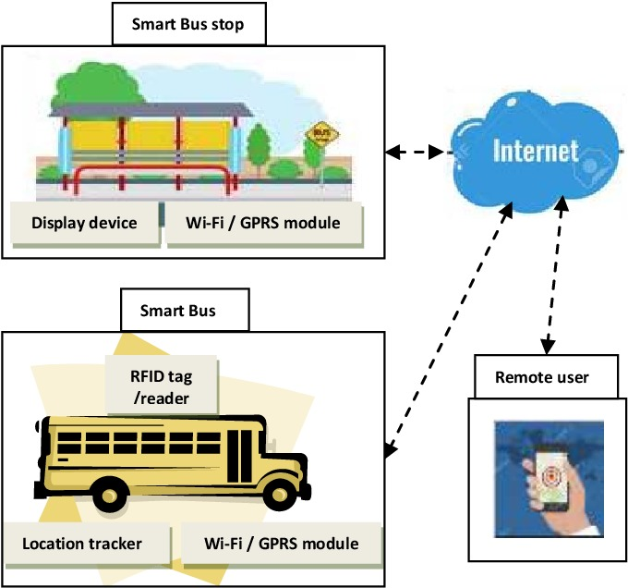

Materials Needed:

1.Software and Development Tools:

Arduino IDE, Platform IO, or Raspberry Pi OS.

2.Data Processing and Analytics:

Microcontrollers, Machine Learning Libraries, Edge Computing.

3.User Interface:

Smartphones, Web Development Tools,GPS Trackers,Bus assets,Bus stop assets,Sensors,LED Display.

4.Networking and Communication:

Routers and Access Points, Cabling.